
PENTECOST UNIVERSITY
Accra, Ghana

INFORMATION SECURITY POLICY
A Framework for Protecting the Information Assets of the University
Course Title | Information Security
Student Name | Patrick Sarpong
Student ID | PUIT/24110072
Submission Date | November/29/2026
Course Assignment

Table of Contents

List of Tables

List of Figures

1. Introduction

1.1 Background
Pentecost University (PU) is a private Christian university in Ghana whose mission is to develop graduates of academic excellence and strong moral character. Like every modern university, PU depends on information systems to fulfil that mission. Student admission and records platforms, the learning management system, library and research repositories, finance and payroll applications, email and collaboration services, campus Wi-Fi and a growing fleet of staff and student devices all create, process and store information of considerable value [1]. That information includes the personal data of students and employees, examination results, research outputs and financial transactions. Its loss or misuse would harm individuals as well as the reputation of the institution.
Higher education is an attractive target for attackers. Open academic cultures, large and constantly changing user populations, widespread use of personal devices and limited security budgets all make university networks hard to defend. The European Union Agency for Cybersecurity reports that ransomware, social engineering and data-related threats remain among the most prominent threats facing organisations [2], while the Verizon Data Breach Investigations Report repeatedly shows that people, through error, stolen credentials or manipulation, are involved in a large share of breaches [3]. A university therefore cannot treat information security as a purely technical matter. It must be governed as an institutional responsibility shared by every member of the community.
This document sets out the Information Security Policy of Pentecost University. It defines what the University protects, who is responsible, which controls must be applied and how compliance will be measured.

1.2 Foundations: The CIA Triad
The policy rests on the three classic security goals known as the CIA triad, shown in Figure 1 [1], [4]. Confidentiality ensures that information is disclosed only to authorised persons. Integrity ensures that information and systems remain accurate, complete and free from unauthorised modification. Availability ensures that information and services can be used by authorised persons when they need them. Every control in this policy exists to protect one or more of these properties. Encrypting laptops protects confidentiality, digitally controlled transcript issuance protects integrity, and redundant power for the data centre protects availability.
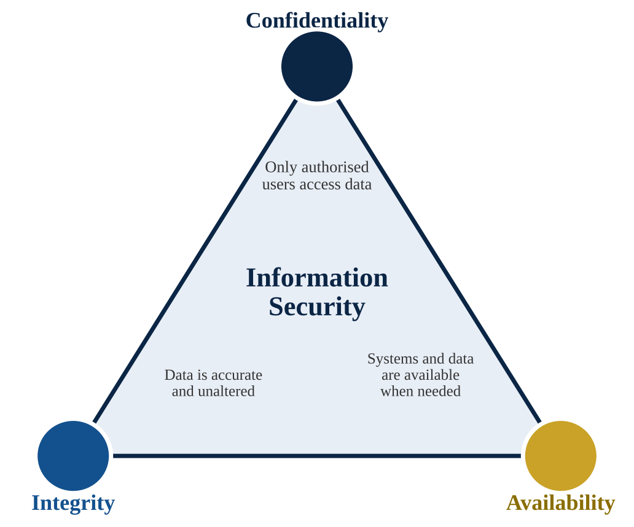
Figure 1. The CIA triad of information security

2. Purpose, Scope and Objectives

2.1 Purpose
The purpose of this policy is to establish a consistent, risk-based framework for protecting the information assets of Pentecost University against unauthorised access, disclosure, alteration, loss and destruction. The framework is aligned with ISO/IEC 27001, the international standard for information security management systems [5], and draws on the six functions of the NIST Cybersecurity Framework 2.0, namely Govern, Identify, Protect, Detect, Respond and Recover [6]. Supporting controls are selected from ISO/IEC 27002 [7]. Alignment with recognised standards helps the University demonstrate due diligence to regulators, partners, donors and students.

2.2 Scope
This policy applies to all students, academic and administrative staff, contractors, visitors, researchers and third-party service providers who access University information or systems, wherever they are located. It covers information in every form, whether electronic, printed or spoken, together with all systems owned or leased by the University, cloud services procured on its behalf and personally owned devices that connect to University networks. Where this policy conflicts with a legal requirement, the stricter requirement prevails. The most important of these are the Data Protection Act, 2012 (Act 843) [8] and the Cybersecurity Act, 2020 (Act 1038) [9].

2.3 Objectives
The University will pursue the following security objectives:
- protect the confidentiality of student, staff and research data;
- preserve the integrity of academic records and financial transactions;
- ensure the availability of teaching, learning and administrative services;
- comply with legal, regulatory and contractual obligations;
- build a culture of security awareness across the university community; and
- detect, respond to and recover from security incidents quickly and effectively.

2.4 Document Control
Table 1 records the administrative details of this policy. Version control allows the University to show auditors which policy was in force at any point in time.
Table 1. Policy document control
Attribute | Detail
Policy title | Information Security Policy
Version | 1.0 (draft for approval)
Policy owner | Chief Information Security Officer (CISO)
Approving authority | Governing Council, on the recommendation of the Vice-Chancellor
Review cycle | Annually, or after any major incident or change in law

3. Governance, Roles and Responsibilities
Effective security requires clear accountability. A policy that belongs to everyone often belongs to no one, so this policy assigns specific duties to named roles. The governance structure adopted by the University is illustrated in Figure 2. The Governing Council holds ultimate accountability and delegates executive responsibility to the Vice-Chancellor. An Information Security Steering Committee, chaired by a senior executive and including representatives of faculties, ICT, finance, human resources and the student body, sets priorities and resolves conflicts between security and operational needs.
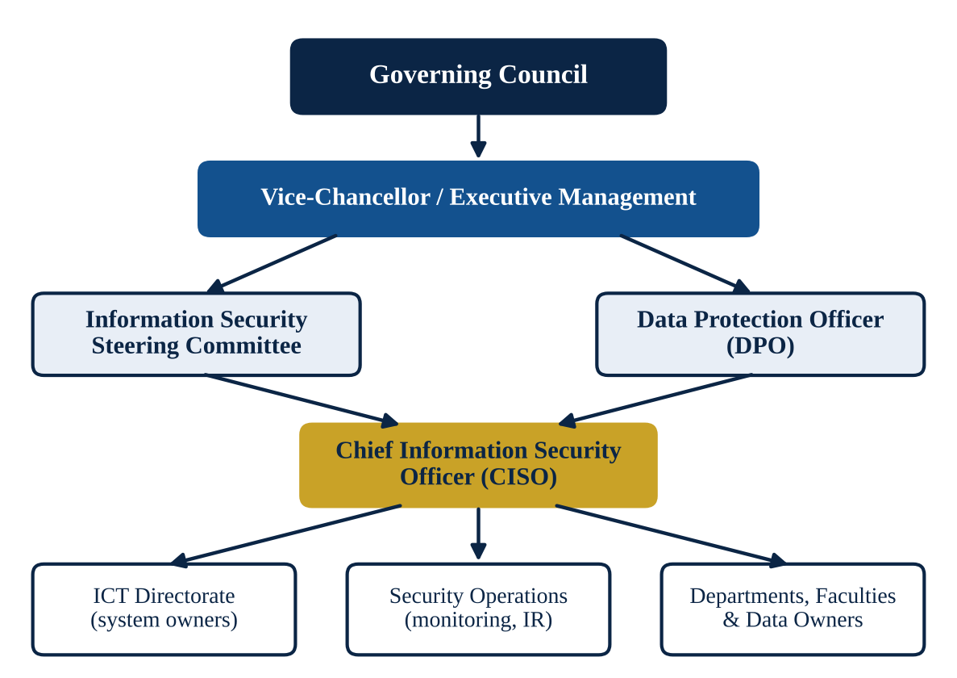
Figure 2. Information security governance structure of Pentecost University
The Chief Information Security Officer (CISO) leads the security programme, maintains this policy and reports to the Steering Committee. The Data Protection Officer (DPO) advises on personal data and acts as the contact point for the regulator. To avoid conflicts of interest, the audit function must remain independent of the teams that operate security controls, consistent with the separation of duties recommended in ISO/IEC 27002 [7]. Table 2 summarises the main responsibilities.
Table 2. Key information security roles and responsibilities
Role | Principal responsibilities
Governing Council | Approves the policy, ensures adequate resources and receives annual security reports.
Vice-Chancellor | Holds executive accountability and ensures security is embedded in strategy and operations.
Steering Committee | Sets security priorities, approves standards and reviews risk and incident trends.
CISO | Owns the policy, manages the security programme, coordinates incident response and reports on performance.
Data Protection Officer | Monitors compliance with Act 843, advises on privacy impact assessments and liaises with the regulator.
ICT Directorate | Implements and operates technical controls, patching, backups and monitoring.
Data owners and heads of department | Classify information, approve access to it and review user rights periodically.
All users | Comply with the policy, protect their credentials and report suspected incidents immediately.

4. Information Classification and Handling
Not all information needs the same level of protection. Applying the strongest controls to everything is costly and impractical, while applying weak controls to sensitive data is dangerous. The University therefore classifies information into four levels, shown in Table 3. The data owner is responsible for assigning the classification when information is created or received, and the classification determines how it may be stored, shared, transmitted and destroyed.
Information must be handled according to its label throughout its life. Confidential and Restricted information must not be stored on personal cloud accounts or unencrypted removable media, and printed copies must be kept in locked storage and shredded when no longer required. Records are retained only for as long as the law or a legitimate business purpose requires. When equipment is retired, storage media must be securely wiped or physically destroyed, and the disposal must be recorded.
Table 3. Information classification scheme
Level | Description | Examples | Minimum handling rules
Public | Approved for release to anyone. | Prospectus, news releases, course catalogue. | Publish only through approved channels.
Internal | For use within the University; low impact if disclosed. | Internal memos, timetables, policies. | Share only on University systems; no public posting.
Confidential | Disclosure could harm individuals or operations. | Student records, staff files, examination scripts, contracts. | Access by role; encrypted in transit and at rest; no personal email.
Restricted | Disclosure would cause severe harm or legal breach. | Payroll, health data, security credentials, unpublished exam papers. | Named-user access, multi-factor authentication, encryption, full audit logging.

5. Risk Management
Security resources are finite, so they must be directed at the risks that matter most. The University adopts a structured risk assessment process based on NIST SP 800-30 [10]. Assessments are performed at least annually, and also before the introduction of a major new system or service. For each asset the assessor identifies relevant threats and vulnerabilities, estimates the likelihood of exploitation and the impact on the University, and calculates a risk score. Likelihood and impact are each rated from 1 to 5, and their product places the risk on the heat map in Figure 3.
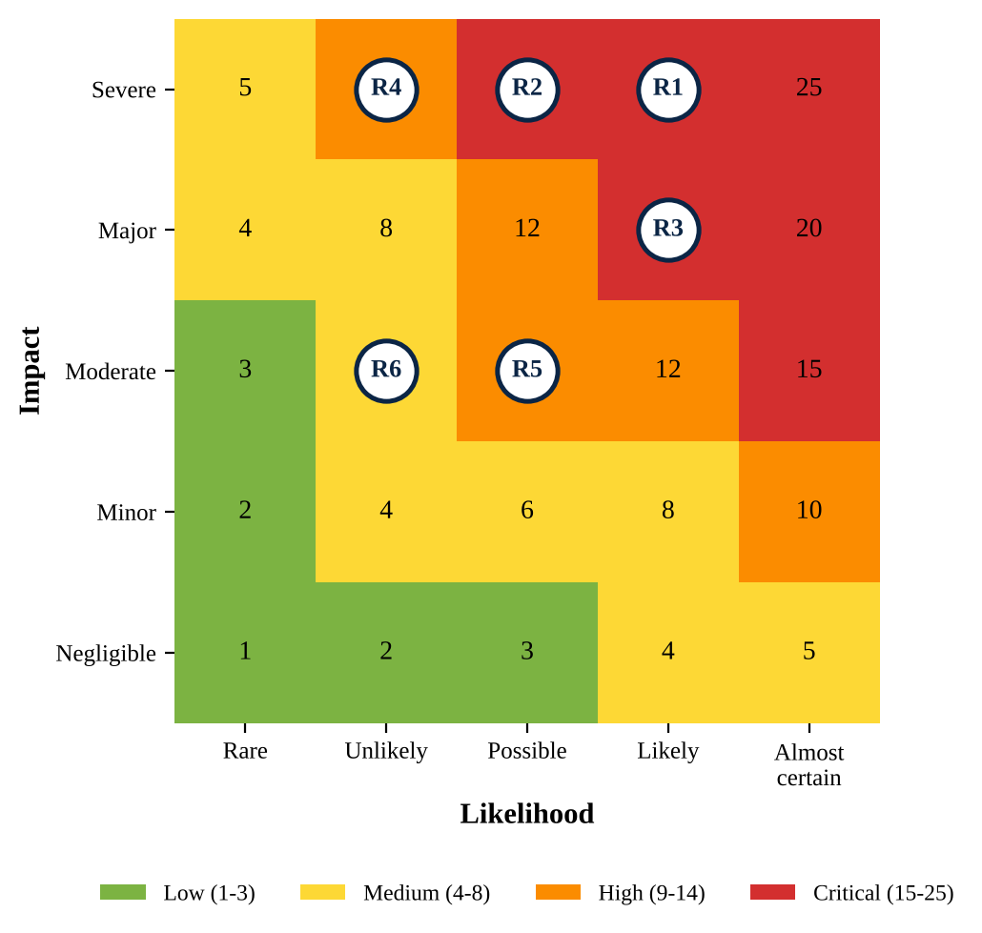
Figure 3. Risk heat map with the University's priority risks
The risks plotted in Figure 3 are described in the sample risk register in Table 4. Ransomware and phishing-led account compromise rank highest because they are both likely and capable of halting teaching and administration for days. The register is maintained by the CISO and reviewed quarterly by the Steering Committee.
Table 4. Sample information security risk register
ID | Risk description | Likelihood | Impact | Score | Primary treatment
R1 | Ransomware encrypts core academic and finance systems | 4 | 5 | 20 (Critical) | Offline backups, EDR, network segmentation
R2 | Student records exposed through compromised privileged account | 3 | 5 | 15 (Critical) | Multi-factor authentication, privileged access management
R3 | Phishing leads to staff email account takeover | 4 | 4 | 16 (Critical) | Awareness training, email filtering, MFA
R4 | Prolonged power or hardware failure in the data centre | 2 | 5 | 10 (High) | UPS, generator, disaster recovery site
R5 | Unpatched web application exploited | 3 | 3 | 9 (High) | Patch management, vulnerability scanning
R6 | Loss or theft of unencrypted staff laptop | 2 | 3 | 6 (Medium) | Full-disk encryption, remote wipe

Each risk is treated by mitigation, transfer, avoidance or acceptance. System owners may accept Low risks, the CISO Medium risks, the Steering Committee High risks, and the Vice-Chancellor Critical risks, which also require a documented treatment plan and review date.

6. Access Control and Identity Management
Access is granted on the principles of least privilege and need to know. Users receive only the permissions their role requires, and sensitive duties are divided so that no single person can complete a high-risk transaction alone, such as approving and releasing a payment. Access is requested formally, approved by the data owner, adjusted when a person changes role and removed on the day a student graduates or a staff member leaves. Access rights are reviewed every six months, and privileged accounts quarterly.
Authentication requirements follow current guidance from NIST SP 800-63B [11]. That guidance favours long passphrases over complex but short passwords, recommends screening new passwords against lists of known compromised passwords, and advises against forcing periodic changes unless compromise is suspected. Accordingly, passwords must be at least 12 characters for ordinary users and 16 for privileged users, must not appear on a breached-password list, and must never be shared. Multi-factor authentication (MFA) is mandatory for remote access, email, administrative accounts and any system holding Confidential or Restricted data. Table 5 sets out the requirements by account type.
Table 5. Authentication and access review requirements by account type
Account type | Authentication requirement | Minimum password length | Access review
Student | Passphrase; MFA for portal and email | 12 | Each semester
Staff | Passphrase; MFA mandatory | 12 | Every 6 months
Privileged / administrator | Passphrase; MFA with separate admin account; session logging | 16 | Quarterly
Third party / contractor | Time-limited account; MFA; sponsor approval | 12 | On expiry of contract

7. Technical Security Controls
No single control is sufficient, so the University applies defence in depth, in which independent layers of protection reduce the chance that one failure leads to a breach [12], [13]. Figure 4 shows the layers that surround University data, from policies and awareness at the outer edge to encryption and backup at the core.
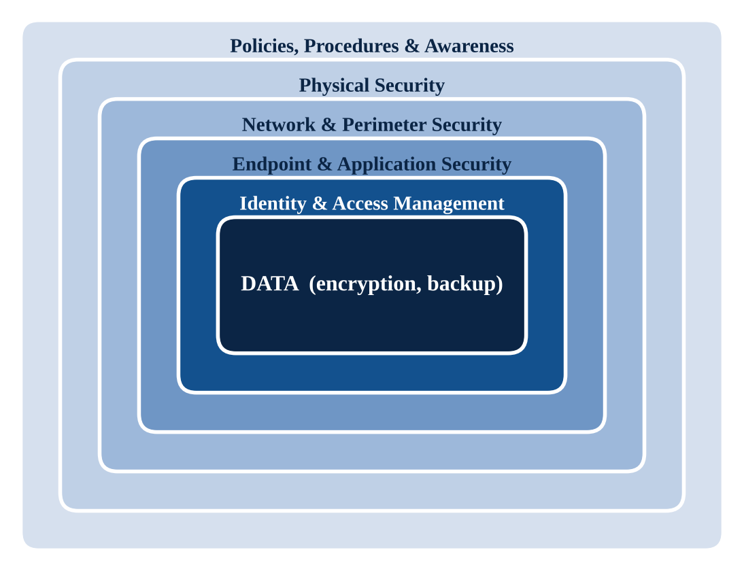
Figure 4. Defence-in-depth layers protecting University data
Network security. The network is divided into separate zones for administration, teaching, servers, research and guest or student Wi-Fi, with firewalls enforcing traffic rules between them. Remote access is allowed only through an encrypted virtual private network with MFA. Intrusion detection and web filtering monitor traffic for malicious activity.
Endpoint and application security. Every University-managed computer runs supported software, endpoint detection and response (EDR) and a host firewall. Critical security patches must be applied within seven days of release and other patches within thirty days. Systems developed or procured by the University must be tested for vulnerabilities before go-live and scanned regularly afterwards.
Cryptography. Data in transit must use TLS 1.2 or higher. Laptops, mobile devices and removable media holding Confidential or Restricted information must use full-disk encryption, and encryption keys must be stored separately from the data they protect.
Logging and monitoring. Authentication events, administrative actions and security alerts are logged centrally, protected from tampering and retained for at least twelve months, so that suspicious activity can be detected and investigated.
Physical security. Server rooms and network cabinets are protected by access control, visitor registers, CCTV and environmental controls.
Mobile, remote and cloud use. Personally owned devices may access University email and the learning platform only with a screen lock, current updates and, for staff, a profile that allows University data to be wiped if the device is lost. Cloud services may be adopted only after a security and privacy assessment by the CISO and the DPO.

8. Security Incident Management
Despite the best preventive measures, incidents will occur, and the speed and quality of the response determines how much damage results. The University follows the incident handling lifecycle described in NIST SP 800-61 [14], illustrated in Figure 5. The cycle begins with preparation, which includes defined roles, contact lists, tools and rehearsed playbooks. It continues with detection and analysis, then containment, eradication and recovery, and ends with a post-incident review whose lessons feed back into preparation.
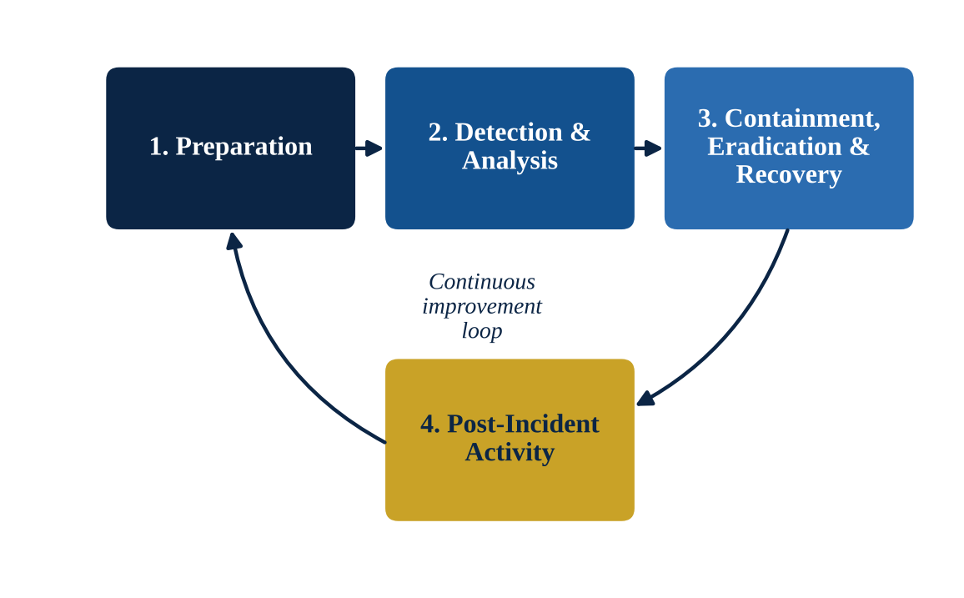
Figure 5. Security incident response lifecycle
All users must report suspected incidents, such as phishing emails, lost devices or unusual system behaviour, to the ICT service desk or the CISO without delay. Reports are triaged and assigned one of the severity levels in Table 6, which determine response times and escalation. A security incident response team, led by the CISO, coordinates technical response, communication and evidence preservation.
Table 6. Incident severity levels and response targets
Severity | Definition | Initial response | Escalation
Critical | Widespread outage, ransomware or confirmed breach of Restricted data | Within 30 minutes | Vice-Chancellor and Steering Committee immediately
High | Compromise of a privileged account or significant service degradation | Within 2 hours | CISO and Steering Committee
Medium | Malware on a single device or contained policy violation | Within 1 working day | CISO
Low | Minor event with no data loss or service impact | Within 3 working days | ICT service desk

Where an incident involves personal data, the DPO must assess whether it must be notified to the Data Protection Commission and affected individuals as required by Act 843 [8]. Significant cybersecurity incidents must also be reported to the Cyber Security Authority in line with Act 1038 [9]. After every Critical or High incident, the CISO produces a written review of root causes and corrective actions.

9. Business Continuity and Backup
Teaching, examinations, admissions and payroll cannot stop for long without serious consequences. The University therefore maintains a Business Continuity Plan and an IT Disaster Recovery Plan based on NIST SP 800-34 [15]. Each critical service has a recovery time objective (RTO), the longest acceptable outage, and a recovery point objective (RPO), the maximum acceptable data loss. The student information system, for example, has an RTO of eight hours and an RPO of one hour.
Backups follow the 3-2-1 principle: three copies of data, on two types of media, with one copy offsite. Because ransomware targets backups, at least one copy must be offline or immutable. Backups are encrypted, monitored daily and test-restored quarterly, and disaster recovery exercises are held annually.

10. Security Awareness and Training
Technology alone cannot protect the University when a single convincing email can persuade a user to hand over credentials, so security awareness is mandatory. New staff complete security induction within their first month, and new students receive an orientation on safe use of the portal, email and Wi-Fi. All staff complete refresher training annually, and privileged staff receive role-specific training. The CISO runs simulated phishing exercises and uses the results to target training rather than to punish individuals. Awareness campaigns use realistic local examples, such as mobile-money fraud and fake scholarship offers.

11. Legal and Regulatory Compliance
The University processes the personal data of thousands of students and employees and must do so lawfully. Act 843 requires that personal data is collected for specified and lawful purposes, kept accurate, retained no longer than necessary and protected by appropriate security safeguards [8]. This policy supplies many of those safeguards. Data subjects have the right to know what information is held about them and to request correction, and the DPO manages these requests. The Cybersecurity Act establishes the Cyber Security Authority and sets obligations for the protection of critical information and the reporting of incidents [9]. The University must also respect software licensing, copyright and contractual security clauses with vendors.
Compliance is verified through annual internal audits, vulnerability assessments and periodic independent penetration testing. Third-party providers that process University data must sign security agreements and are assessed before engagement. Over time, the policy can serve as the foundation for ISO/IEC 27001 certification [5].

12. Policy Enforcement, Exceptions and Review
Compliance with this policy is mandatory. Breaches will be investigated and may result in disciplinary action, suspension of access, termination of contracts or referral to law enforcement. The University will not penalise anyone who reports an incident or weakness in good faith.
Exceptions may be granted only in writing, supported by a risk assessment, approved by the CISO and time-limited, with compensating controls. The policy is reviewed annually, and sooner after a significant incident or change in law, with amendments approved by the Governing Council.

13. Conclusion
Information is among the most valuable assets of Pentecost University, and protecting it is essential to the University's academic mission, financial stability and reputation. This policy provides a structured, practical framework built on confidentiality, integrity and availability, aligned with ISO/IEC 27001 and the NIST Cybersecurity Framework, and tailored to Ghana's Data Protection Act and Cybersecurity Act.
The policy assigns clear accountability, classifies information proportionately, manages risk systematically, restricts access through strong identity controls, layers technical defences and prepares the University to respond and recover. Yet policies achieve nothing unless applied. Success depends on visible leadership, adequate funding, regular testing of controls and a community in which every student and staff member accepts security as their own responsibility.

References
[1] M. E. Whitman and H. J. Mattord, Principles of Information Security, 7th ed. Boston, MA, USA: Cengage Learning, 2022.
[2] European Union Agency for Cybersecurity (ENISA), ENISA Threat Landscape 2023. Athens, Greece: ENISA, Oct. 2023. [Online]. Available: https://www.enisa.europa.eu/publications/enisa-threat-landscape-2023
[3] Verizon, 2024 Data Breach Investigations Report. New York, NY, USA: Verizon Business, 2024. [Online]. Available: https://www.verizon.com/business/resources/reports/dbir/
[4] C. P. Pfleeger, S. L. Pfleeger, and J. Margulies, Security in Computing, 5th ed. Upper Saddle River, NJ, USA: Prentice Hall, 2015.
[5] Information Security, Cybersecurity and Privacy Protection — Information Security Management Systems — Requirements, ISO/IEC 27001:2022, International Organization for Standardization, Geneva, Switzerland, 2022.
[6] National Institute of Standards and Technology, “The NIST Cybersecurity Framework (CSF) 2.0,” NIST, Gaithersburg, MD, USA, Tech. Rep. CSWP 29, Feb. 2024, doi: 10.6028/NIST.CSWP.29.
[7] Information Security, Cybersecurity and Privacy Protection — Information Security Controls, ISO/IEC 27002:2022, International Organization for Standardization, Geneva, Switzerland, 2022.
[8] Data Protection Act, 2012 (Act 843), Republic of Ghana, Accra, Ghana, 2012.
[9] Cybersecurity Act, 2020 (Act 1038), Republic of Ghana, Accra, Ghana, 2020.
[10] Joint Task Force Transformation Initiative, “Guide for conducting risk assessments,” NIST, Gaithersburg, MD, USA, Spec. Pub. 800-30 Rev. 1, Sep. 2012, doi: 10.6028/NIST.SP.800-30r1.
[11] P. A. Grassi et al., “Digital identity guidelines: Authentication and lifecycle management,” NIST, Gaithersburg, MD, USA, Spec. Pub. 800-63B, Jun. 2017, doi: 10.6028/NIST.SP.800-63b.
[12] Center for Internet Security, CIS Critical Security Controls, Version 8. East Greenbush, NY, USA: CIS, May 2021.
[13] R. Anderson, Security Engineering: A Guide to Building Dependable Distributed Systems, 3rd ed. Indianapolis, IN, USA: Wiley, 2020.
[14] P. Cichonski, T. Millar, T. Grance, and K. Scarfone, “Computer security incident handling guide,” NIST, Gaithersburg, MD, USA, Spec. Pub. 800-61 Rev. 2, Aug. 2012, doi: 10.6028/NIST.SP.800-61r2.
[15] M. Swanson, P. Bowen, A. W. Phillips, D. Gallup, and D. Lynes, “Contingency planning guide for federal information systems,” NIST, Gaithersburg, MD, USA, Spec. Pub. 800-34 Rev. 1, May 2010, doi: 10.6028/NIST.SP.800-34r1.

